National Association of Certified Financial Fiduciaries

Hereby confers the designation of

**Certified Financial Fiduciary**®

Upon

James Richard McClanahan II

For having satisfied all professional, educational, and examination requirements to obtain this designation.

Designees agree to abide by the Code of Conduct set forth by the NACFF and the fiduciary pledge of

“Good Faith, Care, and Loyalty to Our Clients Best Interest”

____________________________________________ 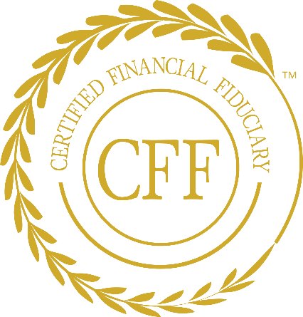 _____________________________________________

Date James R. McClanahan II

Founder|CEO